COMP-699-A Professional Seminar
Structural and Behavioural Model
Employee Leave Request & Approval System
By
Dharani Manupati

1. Use Case Diagram

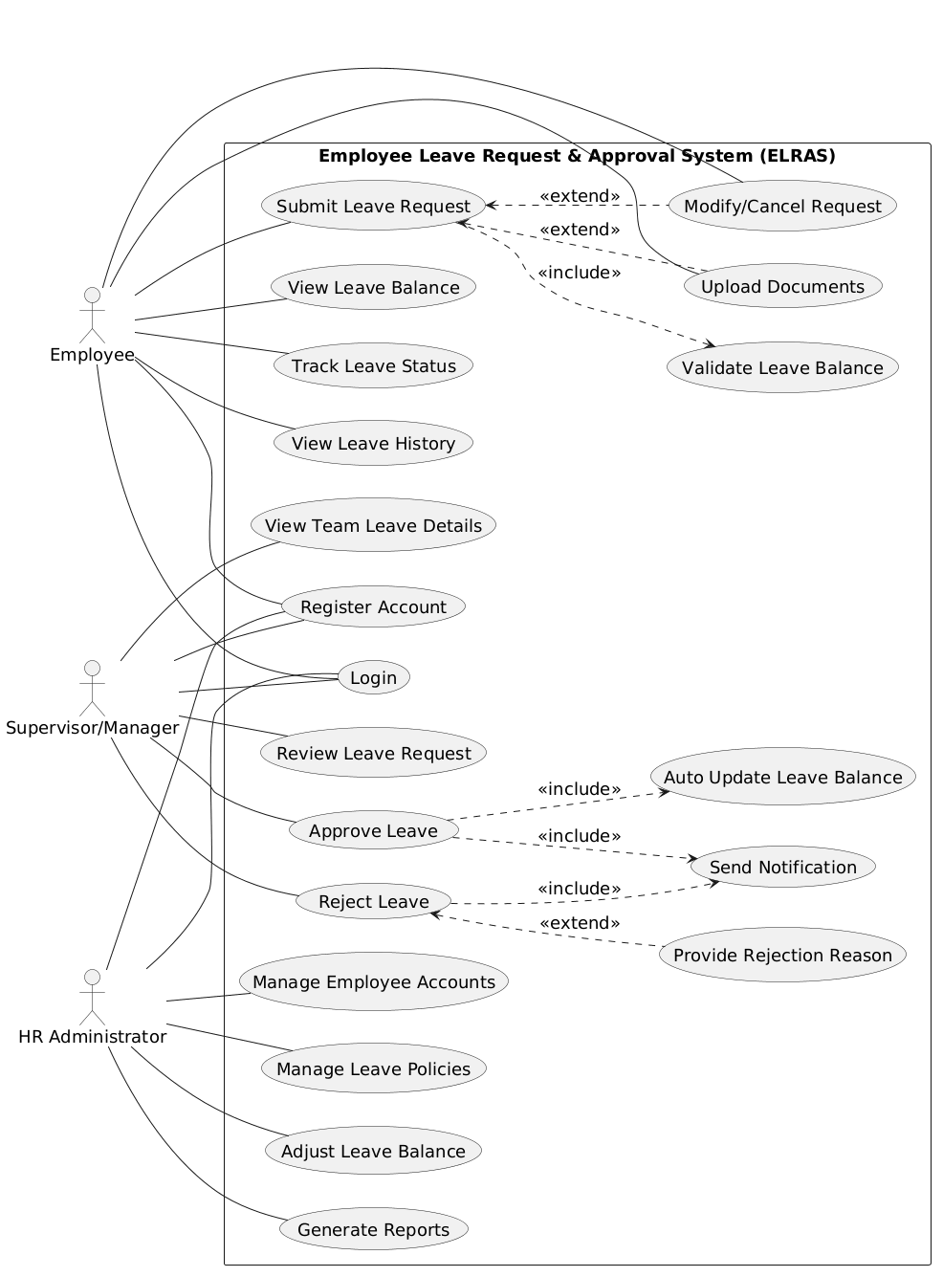
Figure.1 Use Case Diagram
2. Class Diagram
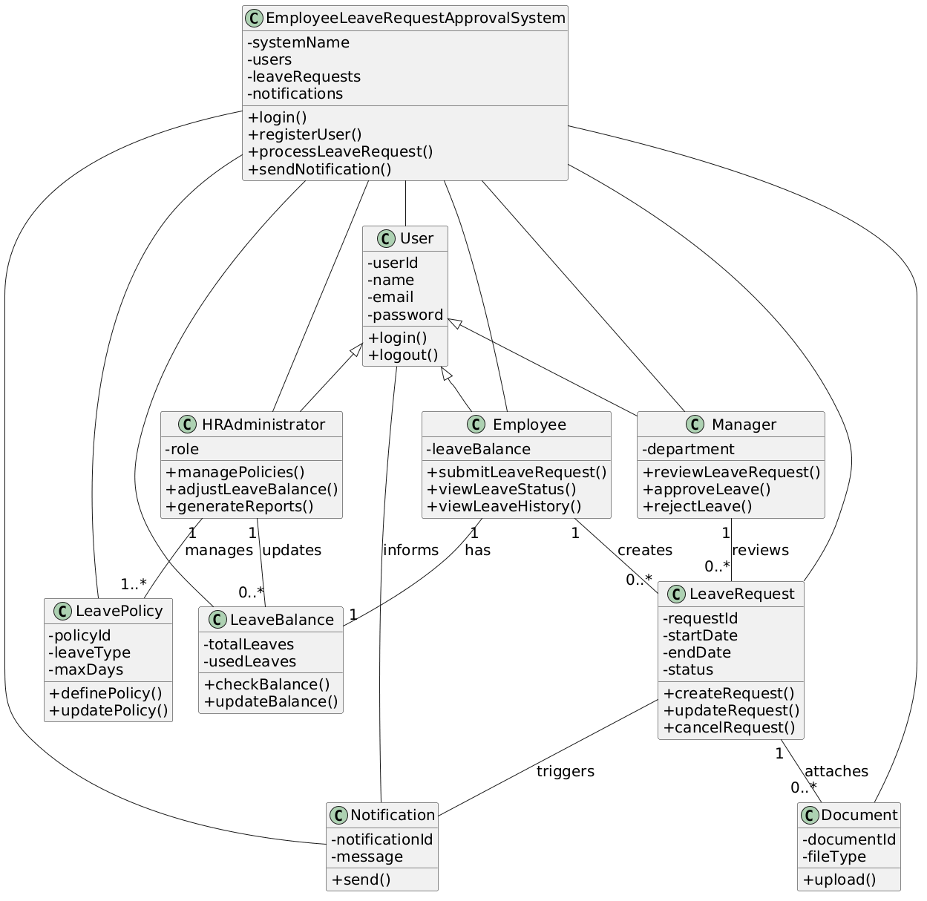
Figure.2 Class Diagram

3. Object Diagram
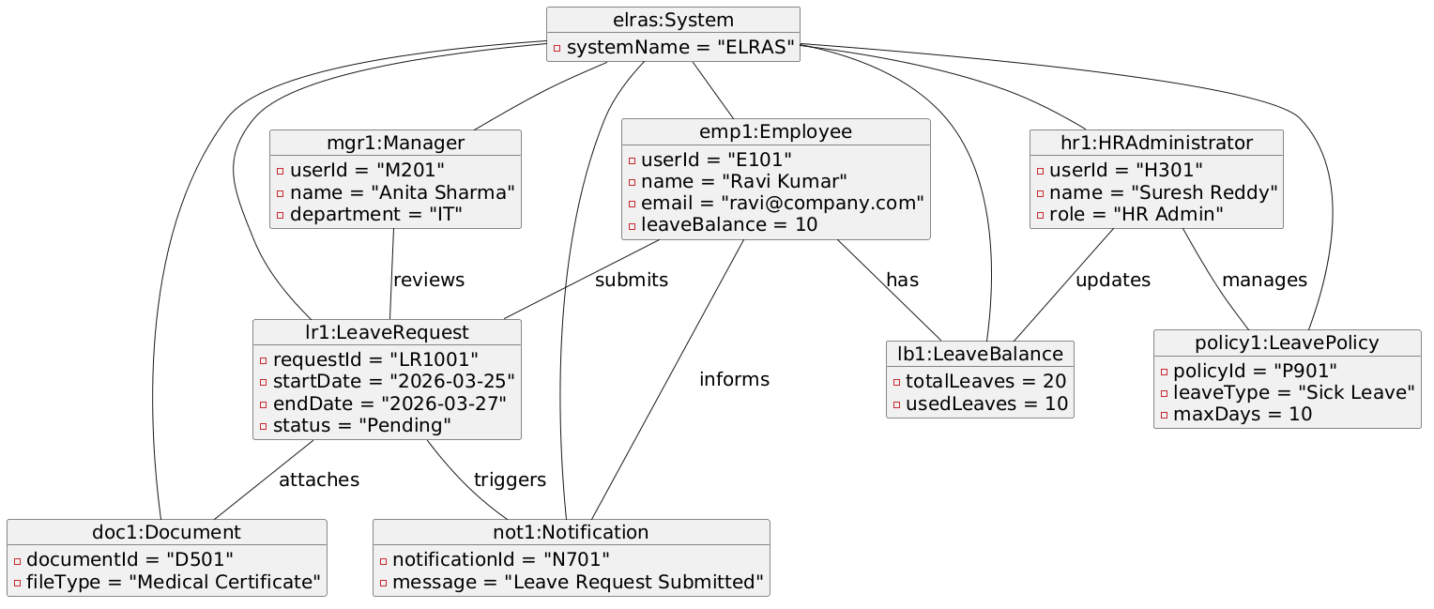
Figure.3 Object Diagram

4. Sequence Diagram
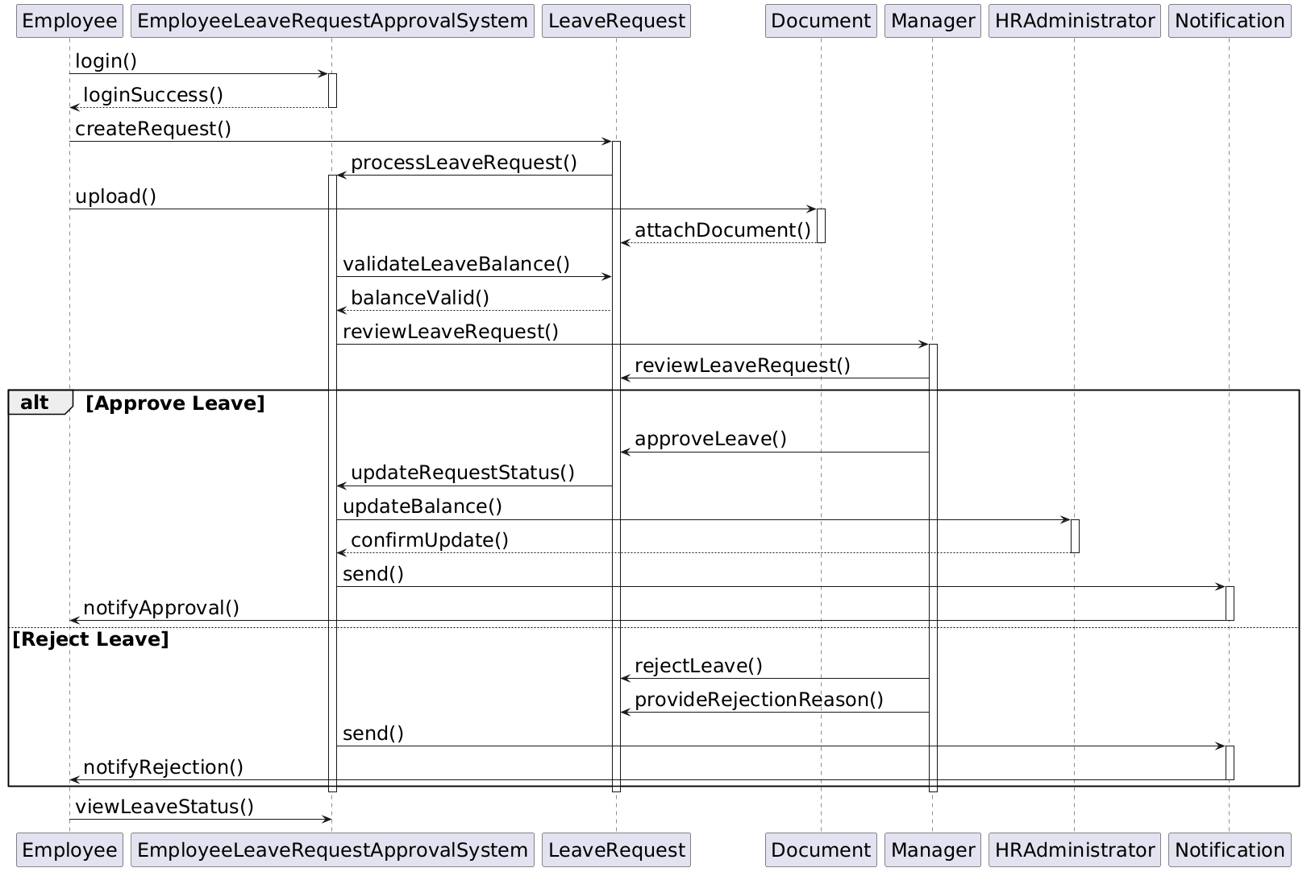
Figure.3 Sequence Diagram
Figure 3 shows sequence diagram how different system components interact step by step when an employee submits a leave request. The process begins with the employee logging into the system. Once the login is successful, the employee creates a leave request. The system processes this request and allows the employee to upload supporting documents, which are attached to the leave request. Next, the system checks whether the employee has enough leave balance. If the balance is valid, the request is forwarded to the manager for review. The manager examines the request and makes a decision. If the leave is approved, the system updates the request status and sends it to the HR Administrator to update the leave balance. After that, a notification is sent to the employee confirming approval. If the manager rejects the request, a rejection reason is provided. The system then sends a rejection notification to the employee. Finally, the employee can view the leave status in the system. Overall, the diagram clearly shows the message flow between objects and how the system handles both approval and rejection scenarios.

5. State Machine Diagram
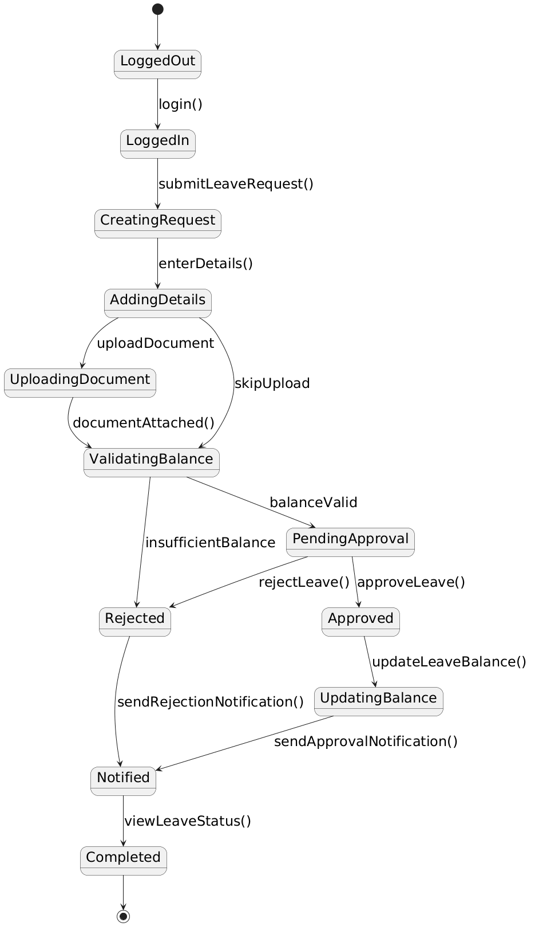
Figure.5 State Machine Diagram
6. Relationships between functional and structural and behavioural Model
The system design was developed step by step by first understanding the functional model, mainly the use case diagram. The use cases clearly showed what actions each actor performs, such as submitting a leave request, approving it, or managing policies. Based on these actions, the important system objects were identified. For example, when the employee submits a leave request, it naturally leads to classes like LeaveRequest, Employee, and Document. Similarly, approval actions helped identify Manager and Notification classes.
The structural model, especially the class diagram, was created by grouping these objects and defining how they are connected. A common parent class called User was introduced to represent shared properties of Employee, Manager, and HR Administrator. This helped reduce repetition and improve clarity. The system class was added to show that all operations are controlled centrally.
After that, behavioral models were designed to show how the system works internally. The sequence diagram was built using the same classes and methods, showing how messages move between objects during a leave request. The activity diagram explained the step-by-step process across different roles, while the state machine diagram focused on how a leave request changes its state from creation to completion.
Overall, each model is connected. The use cases guided the identification of classes, and those classes were used again to build dynamic behavior diagrams. This ensures consistency and a clear understanding of the system.

7. Traceability Table (Use Case to Class Mapping)
Use Case ID | Use Case Name | Related Classes
UC-01 | Login | User, EmployeeLeaveRequestApprovalSystem
UC-02 | Register Account | User, EmployeeLeaveRequestApprovalSystem
UC-03 | Submit Leave Request | Employee, LeaveRequest, EmployeeLeaveRequestApprovalSystem
UC-04 | View Leave Balance | Employee, LeaveBalance
UC-05 | Track Leave Status | Employee, LeaveRequest
UC-06 | Modify/Cancel Request | Employee, LeaveRequest
UC-07 | Upload Documents | Employee, Document, LeaveRequest
UC-08 | Review Leave Request | Manager, LeaveRequest
UC-09 | Approve Leave | Manager, LeaveRequest, LeaveBalance, Notification
UC-10 | Reject Leave | Manager, LeaveRequest, Notification
UC-11 | Provide Rejection Reason | Manager, LeaveRequest
UC-12 | View Team Leave Details | Manager, Employee, LeaveRequest
UC-13 | Manage Leave Policies | HRAdministrator, LeavePolicy
UC-14 | Adjust Leave Balance | HRAdministrator, LeaveBalance
UC-15 | Generate Reports | HRAdministrator, LeaveRequest, LeavePolicy
UC-16 | Manage Employee Accounts | HRAdministrator, User
UC-17 | Validate Leave Balance | LeaveRequest, LeaveBalance
UC-18 | Auto Update Leave Balance | LeaveBalance, EmployeeLeaveRequestApprovalSystem
UC-19 | Send Notification | Notification, EmployeeLeaveRequestApprovalSystem

